Dear Data Science team leader,

I’ve done some analyses on the Gala Groceries data. My analysis includes basic statistics and visualizations (see below). Here are my findings:

* The data in 5 out of 9 columns have uniform distribution. The transactions by customer type, payment type, date, hour and quantity columns are similar in that week.
* Transactions by product id, category, unit price and total show significant variability.
* Such uniform data distributions means that there is no striking pattern that seem interesting to uncover for now.
* The data distributions that do exhibit variability may have interesting insights in them. However, due to the small range of time this data covers the insights from them may not be applicable to longer time range.

Based on my analysis, here are my recommendations:

* Provision more data so that we may uncover significant insights that can be more reliable for use in decision making.
* Provision clear business problems that we may address in our analysis and machine learning solutions.

Best regards,

Nugroho ‘Nugi’ Budianggoro

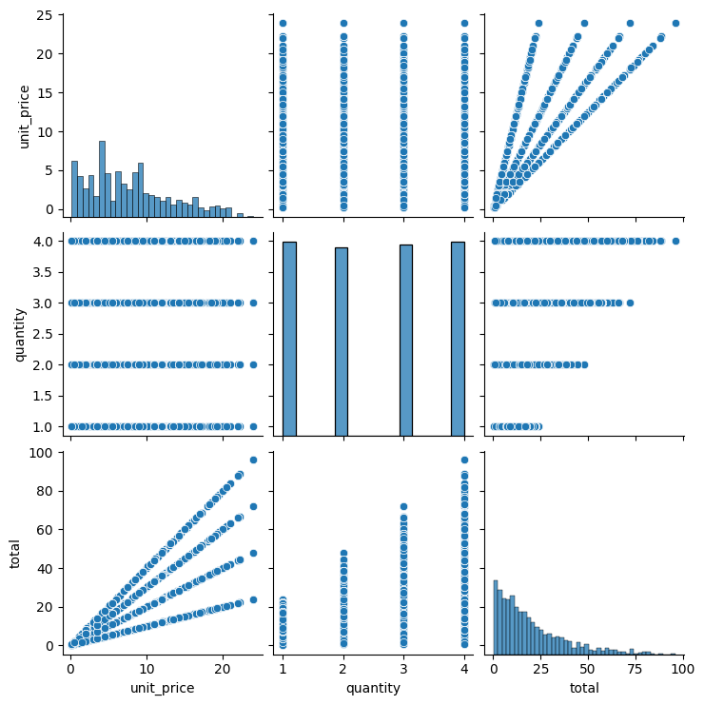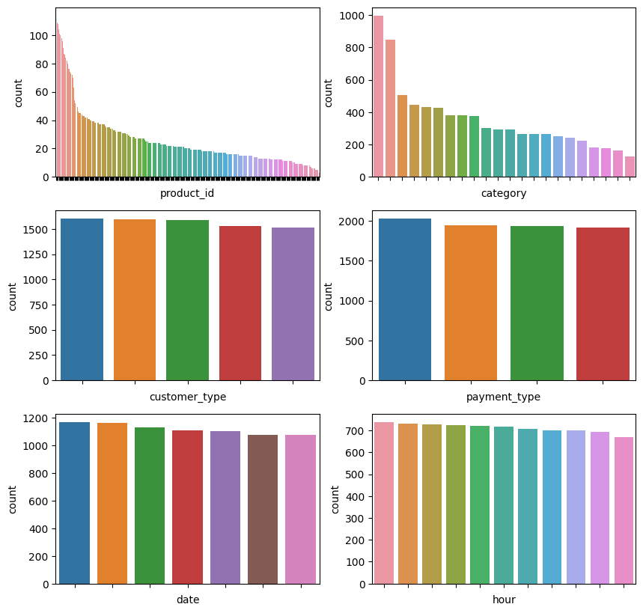***Distributions in Gala Groceries Data***